The student travel grant is to aid students interested in attending the 2019 International Congress of Arachnology.
Awards of up to 1500 USD will be considered for undergraduate and graduate student with limited or no funding support who are presenting authors on a poster or oral presentation at the meeting. In addition to the travel funds, students who demonstrate a need may also receive waived registration costs.
All Applicants must be members of ISA. Priority will be given to individuals who have a demonstrated financial need that cannot be met by other sources (e.g., advisor, department, or university) and based on the following criteria for ranking applications: quality of Abstract, CV, articulation of benefits, and strength of support letter.

To apply, please send an electronic version of the application below
to the organisers at ICA2019NZ@gmail.com, no later than 30 September 2018.

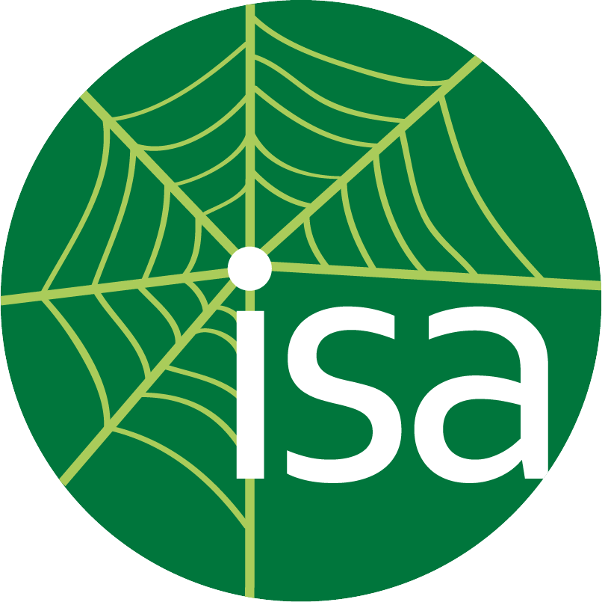

Name:
Institution:
Student Nationality:
Degree sought and expected date of completion:
Title of presentation:
Authors (to be eligible, you must be first and presenting author):
Abstract (no more than 200 words):

____ Poster
____ Oral presentation

Describe how you will benefit from attending this meeting:

Total detailed travel costs:
Item | Cost (in US $) | Comments
Travel
Housing
Food

What travel funds are available to you? Include any potential funds from advisors, department, university or other source.
Source | Amount (in US $) | Applied for or guaranteed?

Total amount requested from Travel Fund:

Do you need the congress registration fee waived?
____ yes*
____ no
*Provide justification for waiver:

In a separate letter, ask your advisor to address the following questions:
- Your qualifications and the quality of the research you plan to present.
- Whether additional funding will be available either from your advisor or from other sources.

Note: please make sure that your advisor submits your letter to the organisers by the deadline as it is a significant portion of your application score.

All material should be sent via email to:
ICA2019NZ@gmail.com
no later than 30 September 2018

